**Installation of Jenkins on Ubuntu 16.04**

Need to take **One Ubuntu 16.04 server and set all the configurations which includes**

**Pre requisite**

**Java Version 1.8 above**

sudo apt-get install openjdk-8-jre

Maven

apt-get install maven

**Install Jenkins**

1. **wget -q -O - https://pkg.jenkins.io/debian/jenkins-ci.org.key | sudo apt-key add –**
2. **echo deb https://pkg.jenkins.io/debian-stable binary/ | sudo tee /etc/apt/sources.list.d/jenkins.list**
3. **sudo apt-get update**
4. **sudo apt-get install jenkins**
5. **sudo systemctl start jenkins**
6. **sudo systemctl status jenkins**

**If everything went well, the beginning of the output should show that the service is active and configured to start at boot:**

● jenkins.service - LSB: Start Jenkins at boot time

Loaded: loaded (/etc/init.d/jenkins; bad; vendor preset: enabled)

Active:active (exited) since Thu 2017-04-20 16:51:13 UTC; 2min 7s ago

Docs: man:systemd-sysv-generator(8)

**By default, Jenkins runs on port 8080, so we'll open that port using ufw:**

sudo ufw allow 8080

We can see the new rules by checking UFW's status.

sudo ufw status

To set up our installation, we'll visit Jenkins on its default port, 8080, using the server domain name or IP address: <http://ip_address_or_domain_name:8080>

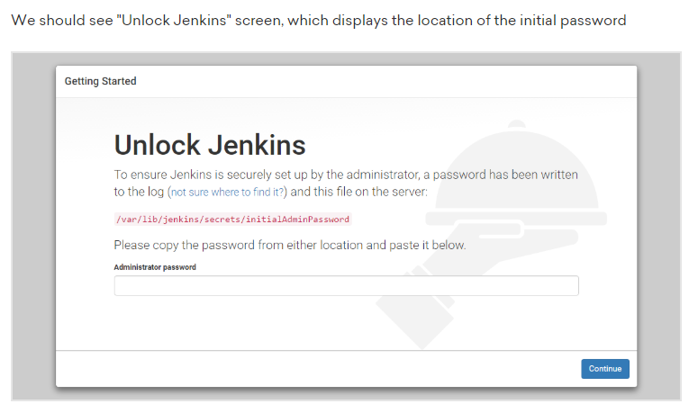

sudo cat /var/lib/jenkins/secrets/initialAdminPassword

If any further quires please refer the URL

<https://www.digitalocean.com/community/tutorials/how-to-install-jenkins-on-ubuntu-16-04>